**EDA and Business Insights for eCommerce Transactions Dataset**

This report summarizes the findings from the exploratory data analysis (EDA) of the eCommerce Transactions dataset and provides actionable business insights.

**Insight 1: Regional Sales Performance**

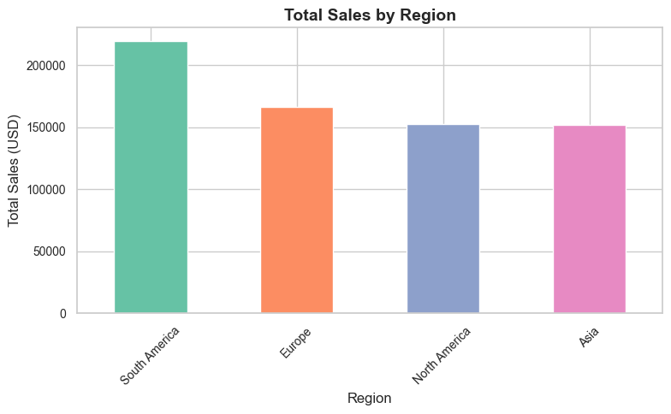

* Sales are highest in South America and lowest in Asia and North America.
* **Action**: Focus marketing efforts on underperforming regions like Asia and North America to boost sales.

**Insight 2: Seasonal Transaction Trends**

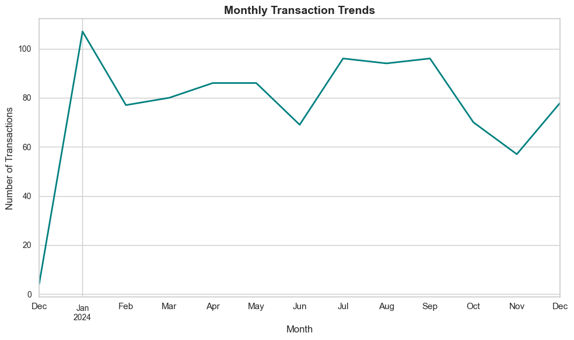

* Transactions peak during Q3 and dip in Q4 (holiday season).
* **Action**: Launch targeted promotions and discounts during Q4 to drive sales.

**Insight 3: Popular Product Categories**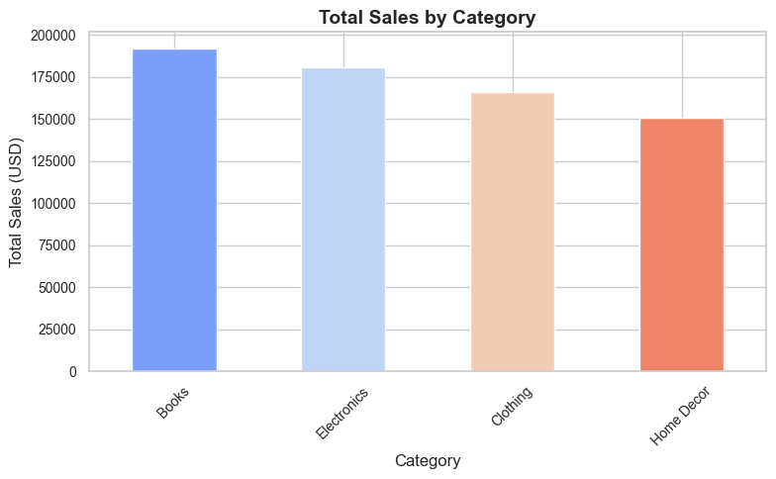

* Electronics and Books are the top-selling categories.
* **Action**: Increase inventory and marketing efforts for these categories.

**Insight 4: High-Value Customers**

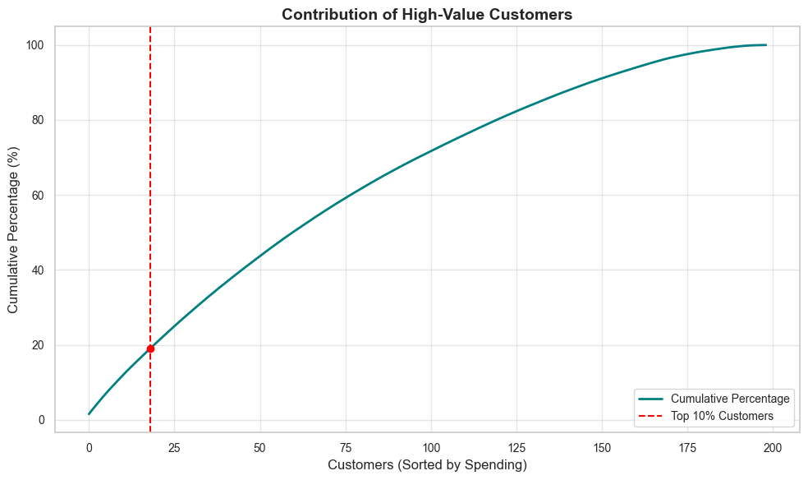

* Top 10% of customers contribute to 19.11% of total sales.
* **Action**: Implement loyalty programs and personalized offers to retain high-value customers.

**Insight 5: Pricing Strategy**

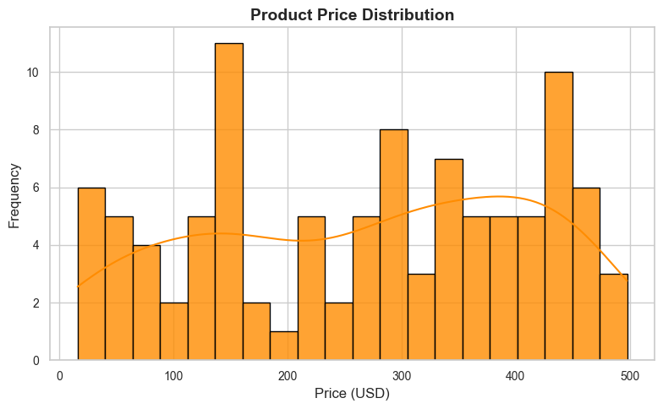

* Products priced between 320−460 have the highest sales volume.
* **Action**: Introduce more products in this price range and bundle the less frequently sold items.